Intelligent Video Recorder

10CH 4K Smart NVR
NL-NV10

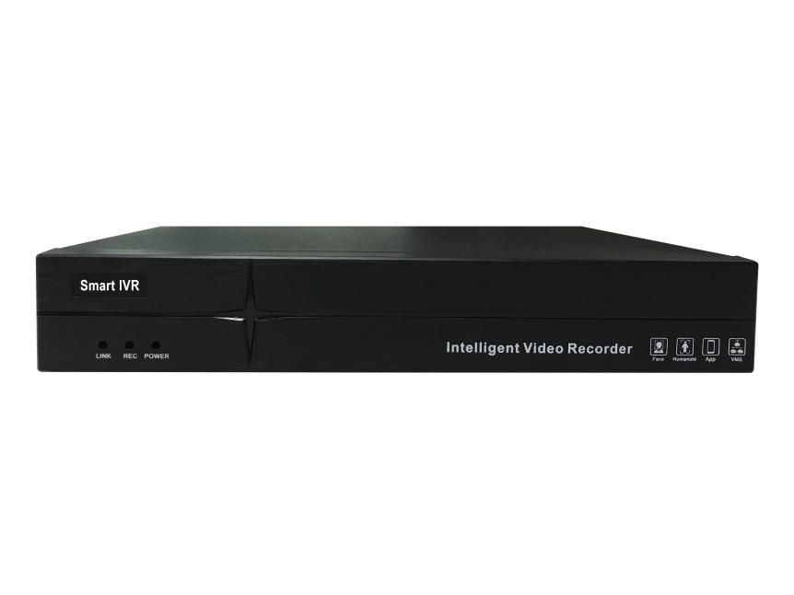







Smart 265 ONVIF SLINK IMS APP







Modify Light Mode Human Detect Vehicle Detect Retrograde Absent Alarm

Introduction:

Support Smart 265 and HTML5 latest technology, support 10 CH 4K IP camera input and output, support smart analysis IPC, 4CH 1080P playback, 1 pcs HDD (max 16TB), 1CH VGA, 1 CH HDMI, support to upgrade IPC remote, modify IP camera address and light board parameters, support audio, support P2P, 2 pcs USB port

Features：
● Support 10 Channels IPC input（8MP/D1+10 CH Preview+4CH playback）
● Support samrt 265, H265,H264 compression format
● Support synchronized recording,remote view,backup recording in MP4 format, mobile view
● Support VGA/HDMI
● Support preview image and playback image electronic amplification
● Support RTSP,GB28181, ONVIF protocol
● Support RTMP stream push, support DDNS,UPNP...etc
● Support alarm capture,send alarm information by email
● Support WEB, mobile view,IMS surveillance
● Support IPC smart analysis:motion detection,alarm input, human detection,area intrusion, line crossing detection,loitering detection, absent alarm, vehicle illegal parking,retrograde detection
● Support channel patrol grouping
●Support network inspection-network traffic monitor, network-detect packet,network diagnosis..etc
● Support max 4CH 1080P playback
● Support 10CH 4K decode and 4K display output
● Support HTML5 remote login operation
● Support to add IPC manually or automatically in LAN
● Support to upgrade IPC online and by memory
● Support to maintain IPC under private protocol, including restore, restart, enable or disable all network function
● Support disconnected network supplement function, optimize bandwidth incoming up to 64M

Specification：
System | Embedded LINUX design, pure hard decoding, watchdog, hard disk storage, HDMI HD display, IP network video access
Video Input | HD IPC input, support dual code stream access for each IPC, support auto search, auto add, auto recording, auto preview, and realize zero debugging
Video Input | Incoming bandwidth 64Mbps;
Video Output | 1CH HDMI output,1CH VGA output,Same origin as HDMI;resolution:  3840×2160,1920×1080,1440×900,1280×1024,1280×800,1024×768
Video Output | Support IMS preview , support APP preview
Video Output | Support split,1/2/4/6/8/9/10 realtime preview
Recording resolution | Support 720P/960P/1080P/3MP/4MP/5MP/4K
Video Decoding Parameters | Support Smart265/H.265/H.264 decode
Video Decoding Parameters | NVR playback 4 CH (1*4K) ; max support 4 CH playback on IMS
Audio | G.711; support HDMI audio output,support audio output（3.5mm hole), support audio/recording with audio preview and playback on IMS
Storage Management | 1 pcs SATA port, max support 16TB HDD
Storage Management | Support timing recording, alarm recording, timing and alarm recording; alarm recording includes (motion detection, alarm input, human detection, line-crossing detection, area intrusion, personnel linger, absent alarm, vehicle parking violation, and vehicle retrograde)
Storage Management | Support the backup of external USB storage devices (such as ordinary USB flash disk and mobile hard disk)
User Management | Max support 32 users
Network Port | 1 pcs RJ45 port, support 10/100M self-adaptive; support TCP/IP,IPv4,  DHCP,NTP,RTSP,ONVIF,P2P,SMTP, GB28181...etc network protocol;
Peripheral Port | 2 pcs USB2.0 port(rear ); support mouse, USB upgrade, import and export
Alarm Port | No
Front Panel | Support 3 kinds of indicator light, including power, recording, data transfer
Buzzer | Support buzzer alarm
Function | Support preview/recording/transfer/remote service, support alert linkage, support IMS monitor software, support P2P cloud service
Working Temperature | -10℃～＋55℃
Working Humidity | 10%～90%
Power Consumption | DC +12V/2A ,≤2W power consumption (without HDD)
Size (mm) | Size 210*255*42mm(W×D×H), support wall installation
Weight（Ｋg) | N.W.: 0.9Kg; G.W: 1Kg（No HDD）
Package | 10 pcs/CTN 610mm×380mm×340mm; weight: 10KG

Size
